**IT Project Management (IT3040)**

**Assessment on Tools**

|  |  |  |  |
| --- | --- | --- | --- |
| **Group Number** | **125** | | |
| **Name** | | **Registration No** | **Signature** |
| Wimalasooriya S.A.N | | IT21034268 |  |
| Thenabandu W.S.D | | IT21104008 |  |
| Balachandra B.A.D.K.M | | IT21119026 |  |
| Samaraweera H.M.C.D | | IT20198404 |  |
| Pasan M.G.R | | IT21057588 |  |

**Table of Contents**

Contribution to the project 1

Azure Board 2

GitHub 8

Selenium 12

# Contribution to the project

|  |  |
| --- | --- |
| **Student Reg. No** | **Responsible Tasks** |
| IT21034268 | **Donee Functionality** |
| IT21104008 | **User Account Management** |
| IT21119026 | **Payment Management** |
| IT20198404 | **Donation Management** |
| IT21057588 | **Feedback Management** |

# Azure Board

1. **Work Items**

|  |  |
| --- | --- |
| **Name in Azure Board** | **Student Registration No** |
| Samaraweera H. M. C. D. | IT20198404 |
| Thenabandu W.S.D | IT21104008 |
| Pasan M.G.R | IT21057588 |
| Wimalasooriya.S.A.N. | IT21034268 |
| Balachandra B.A.D.K.M | IT21119026 |

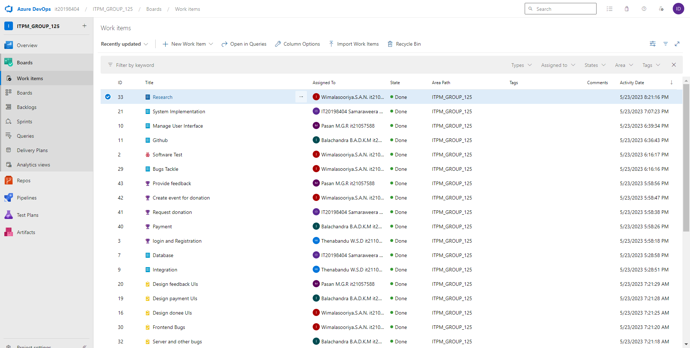

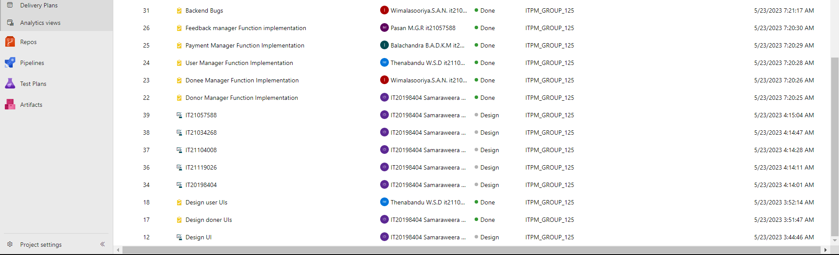

1. **Sprints**

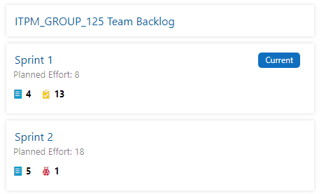

1. **Backlog items related to sprint 1**

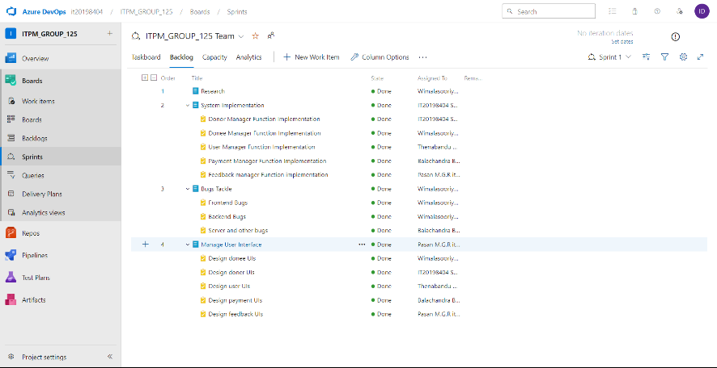

1. **Backlog items related to sprint 2**

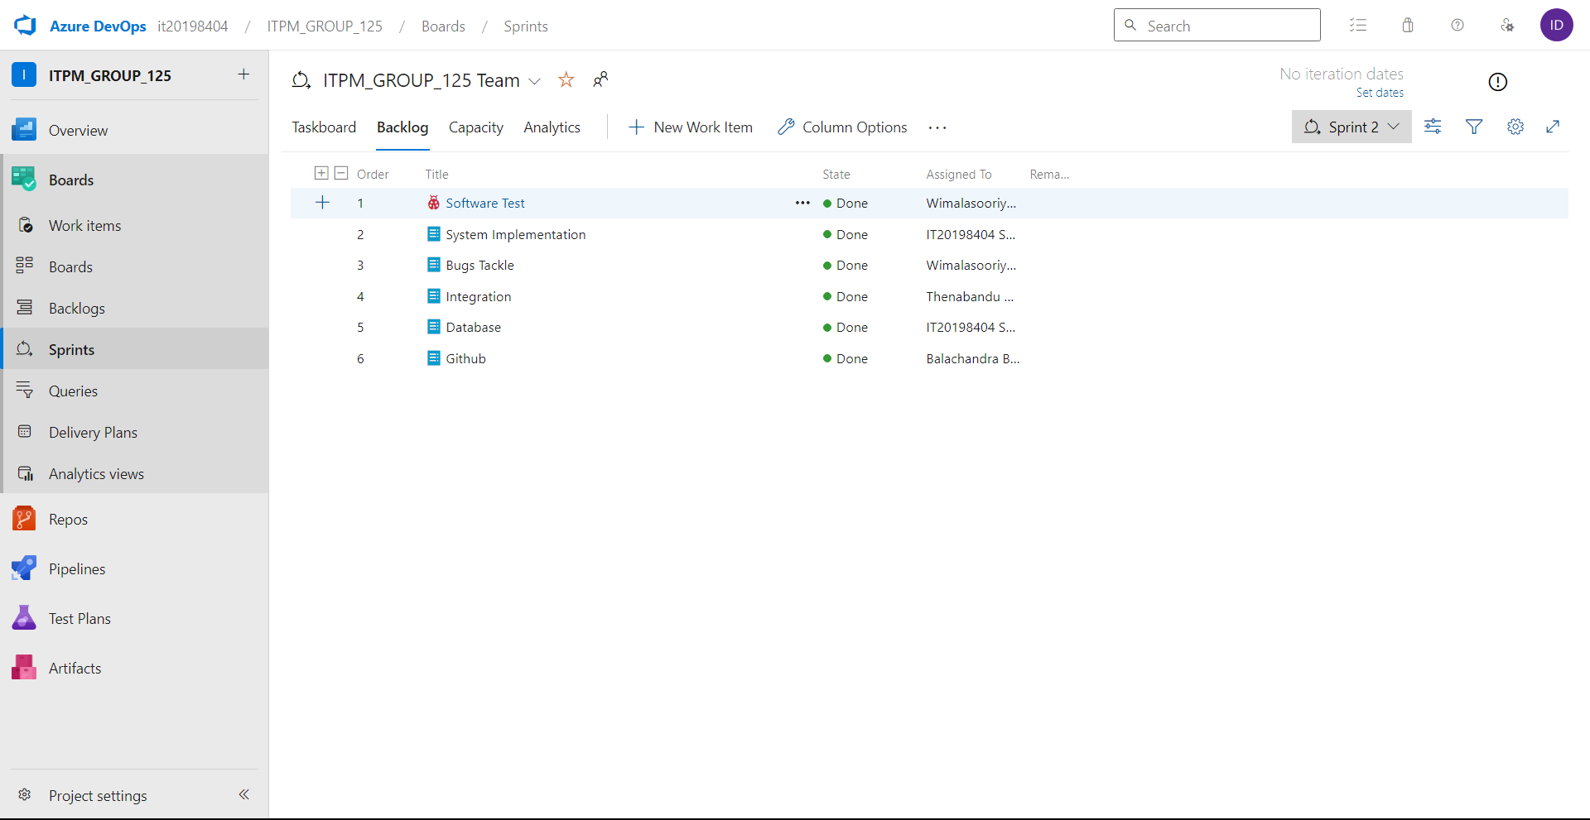

1. **Boards**

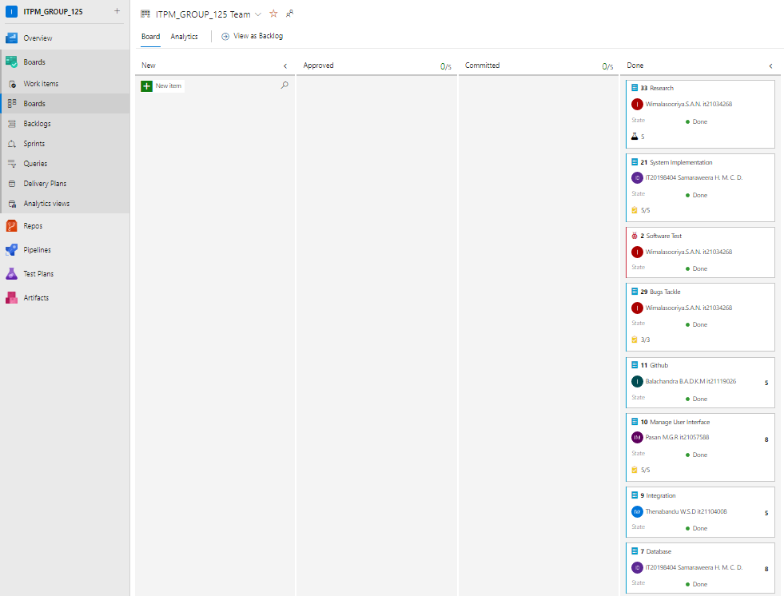

1. **Feature**

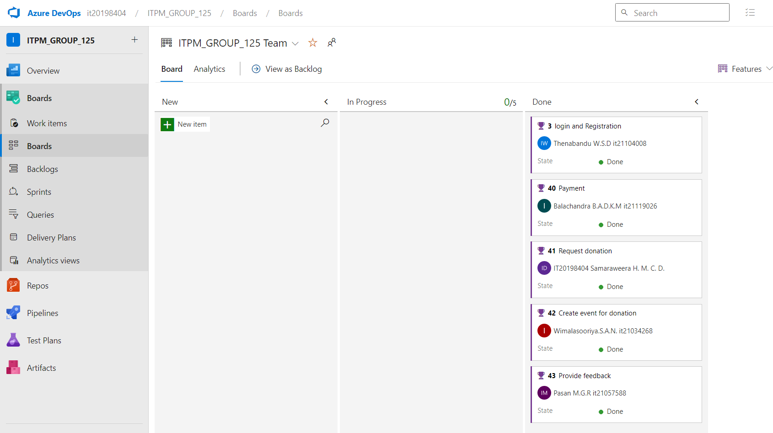

1. **Sprint burndown chart**

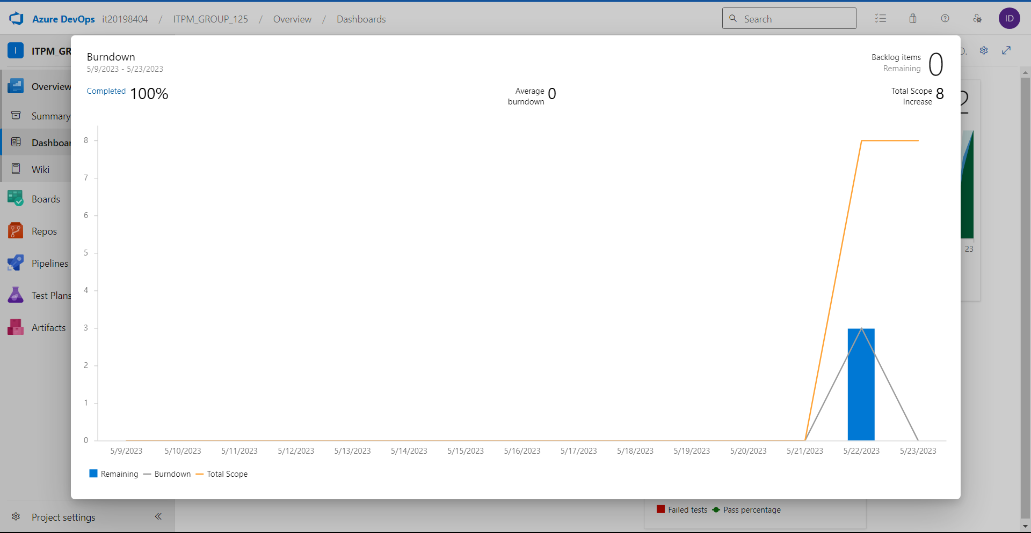

1. **Bug burndown chart**

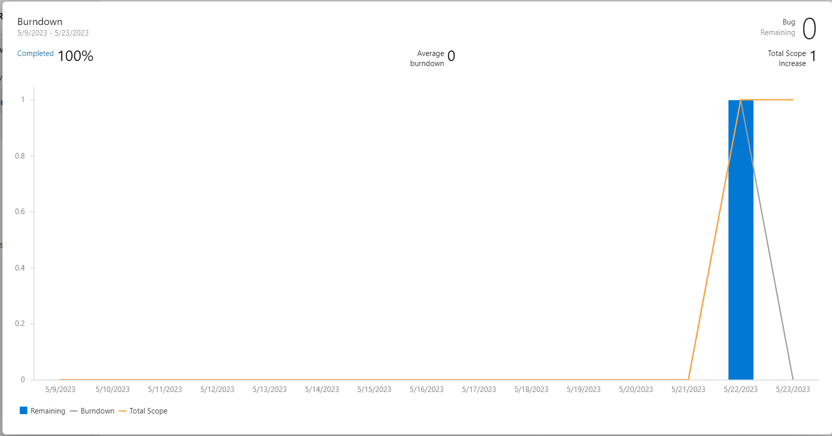

1. **Cumulative flow diagram**

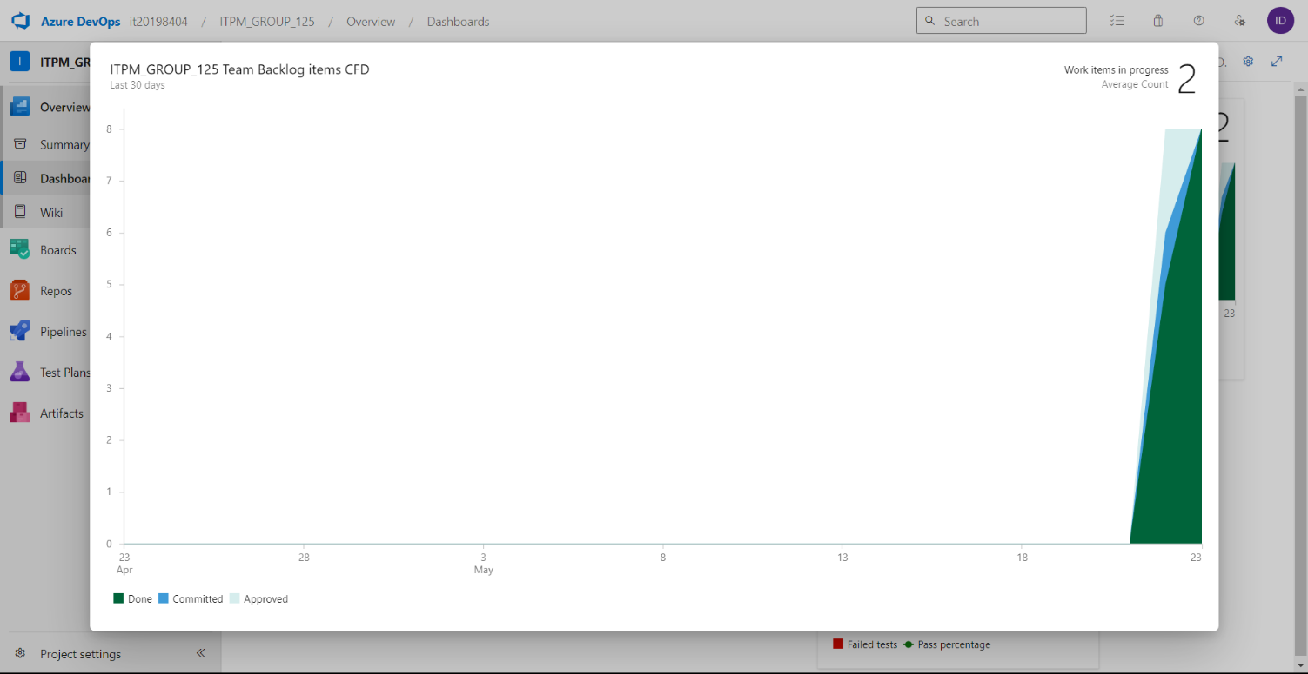

1. **Test result trends**

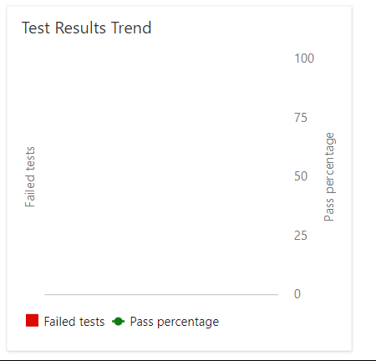

# 

# GitHub

GitHub Link: https://github.com/it21119026/ITPM.git

1. **Repository view**

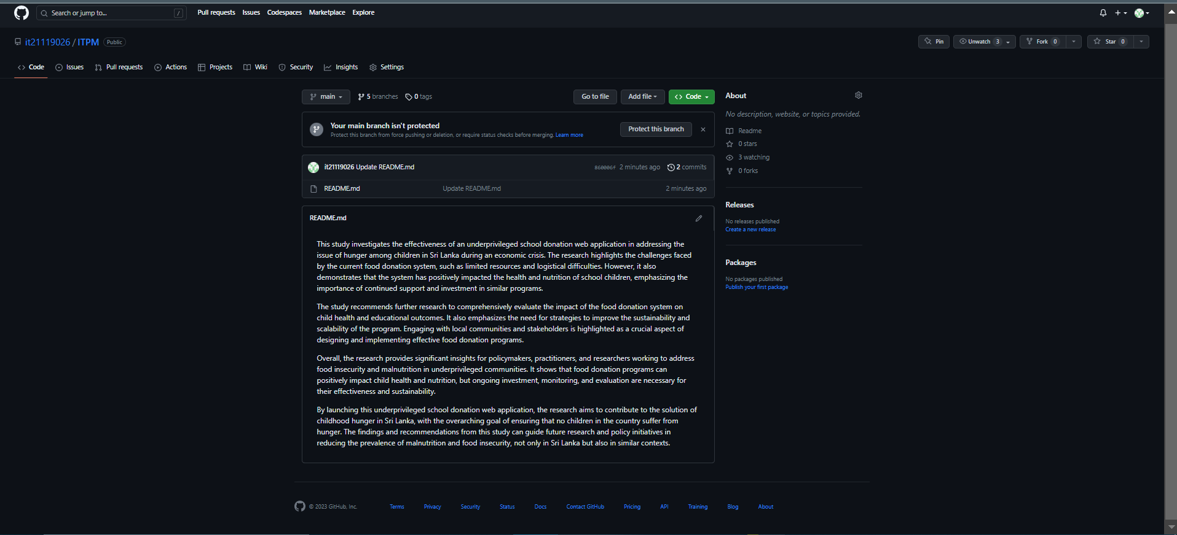

1. **File setup**

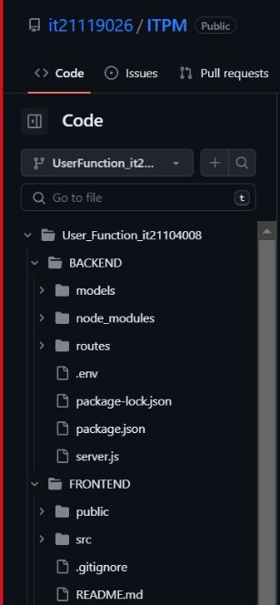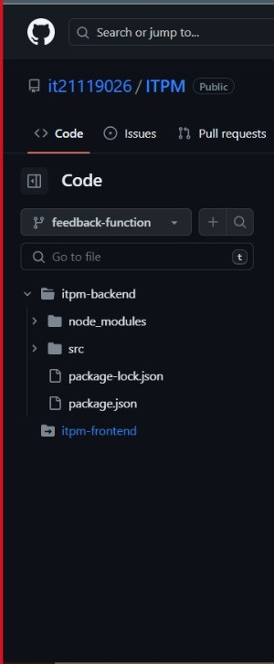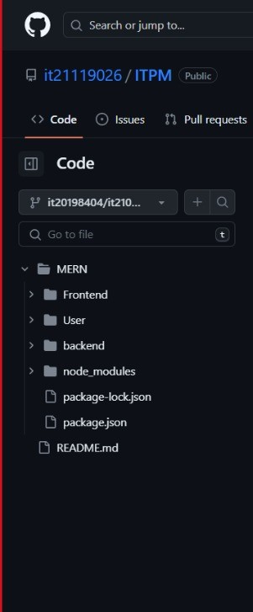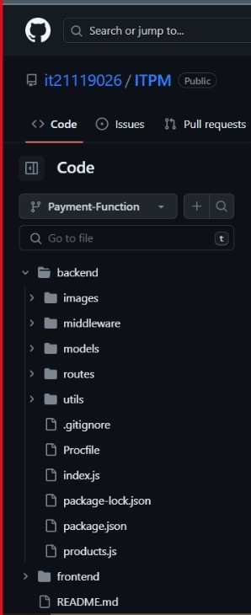

1. **Branches**

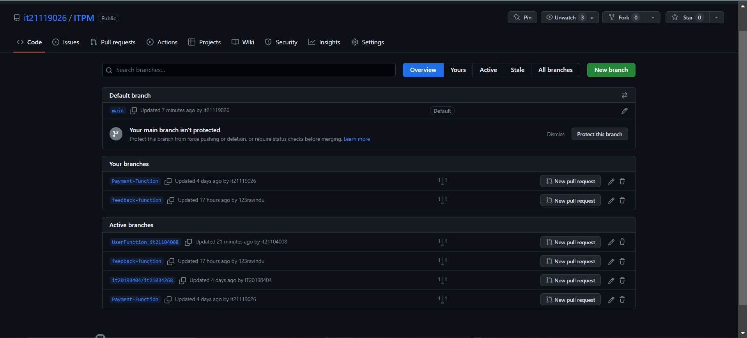

1. **Contributors**

|  |  |
| --- | --- |
| **GitHub Username** | **Student Registration No** |
| IT21034268 | IT21034268 |
| IT21104008 | IT21104008 |
| 123ravindu | IT21057588 |
| IT21119026 | IT21119026 |
| IT20198404 | IT20198404 |

1. **Commit graph**

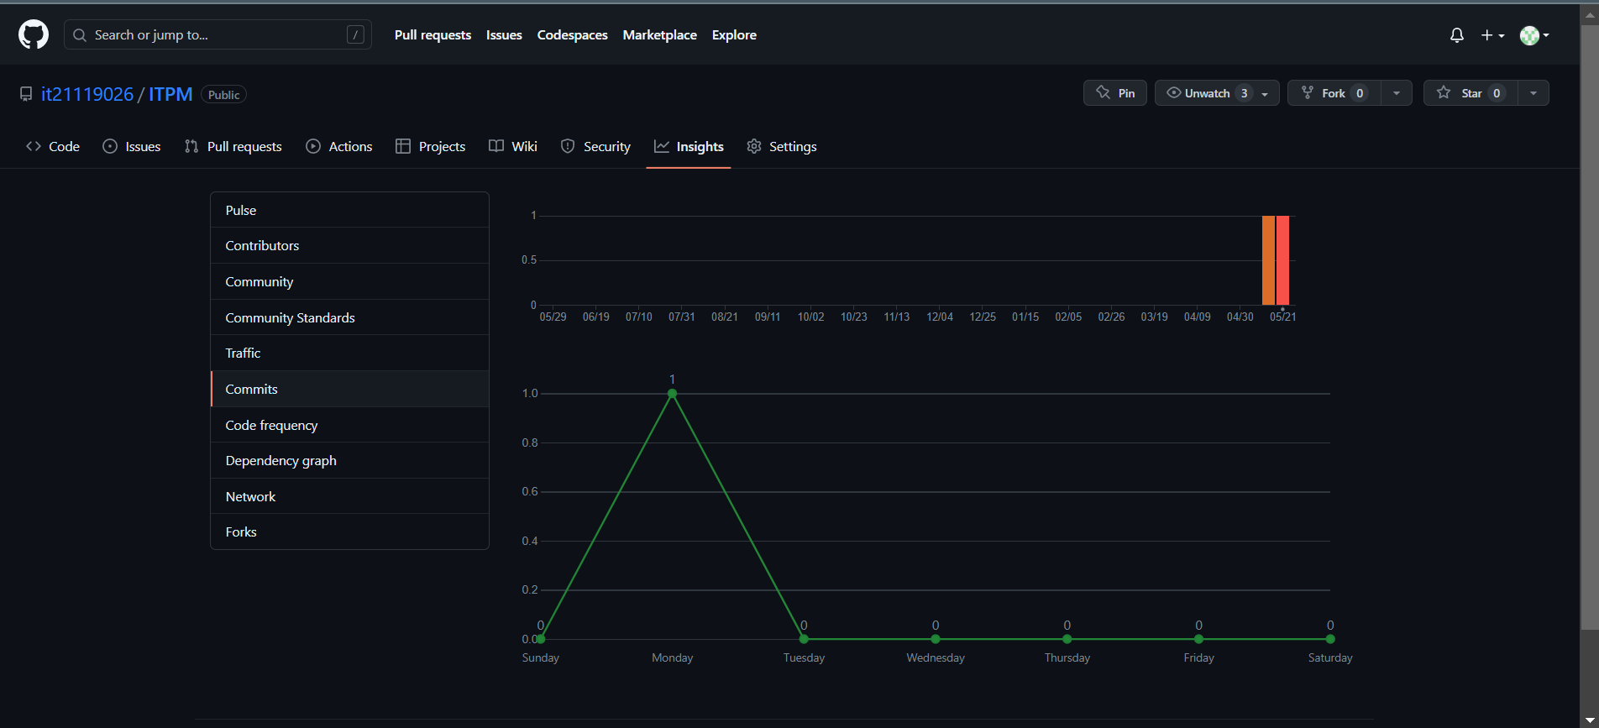

1. **Commit History**
2. **Code Frequency**

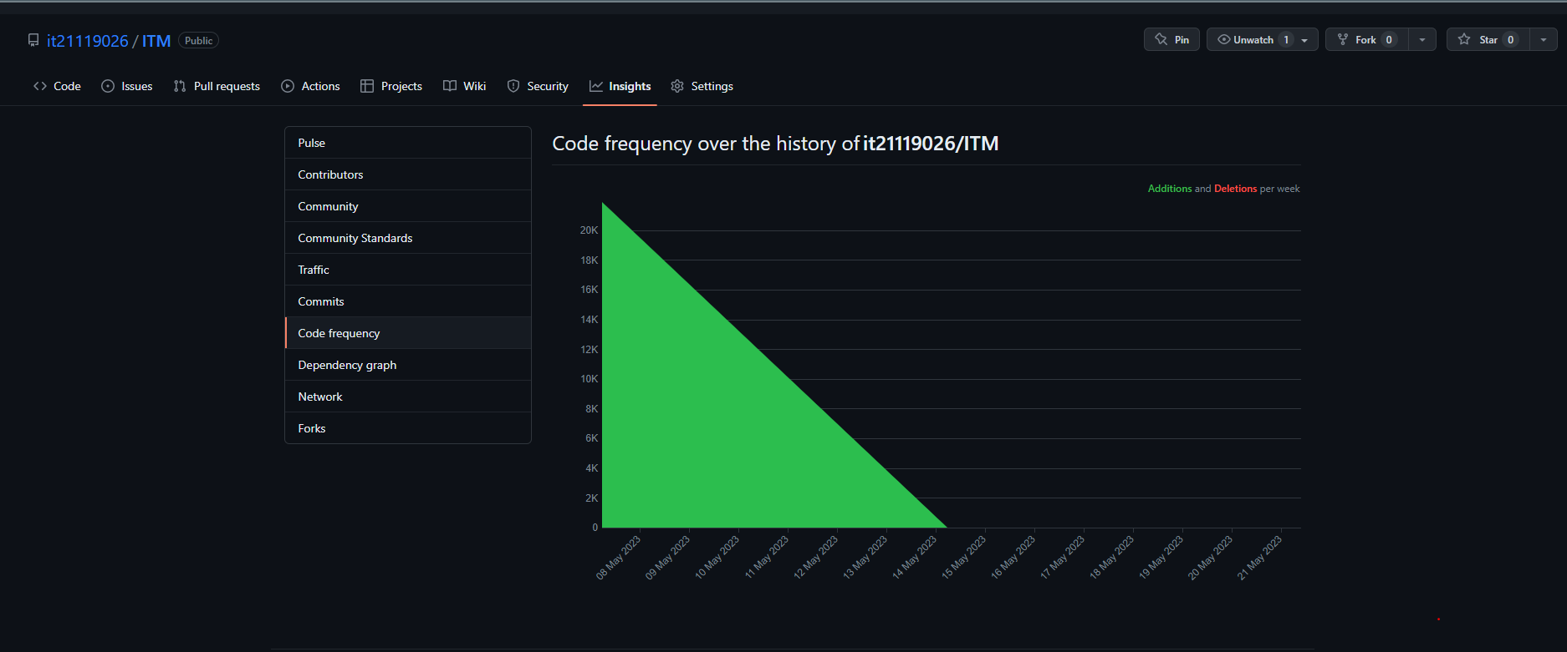

1. **Pulse**

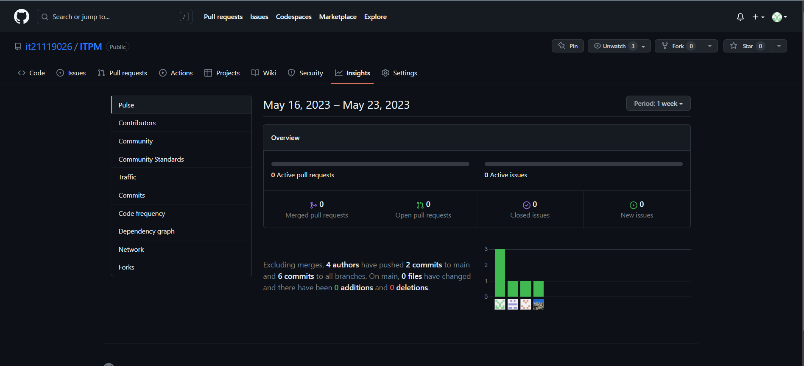

1. **ReadMe.md**

# Selenium

1. **Selenium IDE with the base URL**

[**http://localhost:3006**](http://localhost:3006) **,** [**http://localhost:3000**](http://localhost:3000)

1. 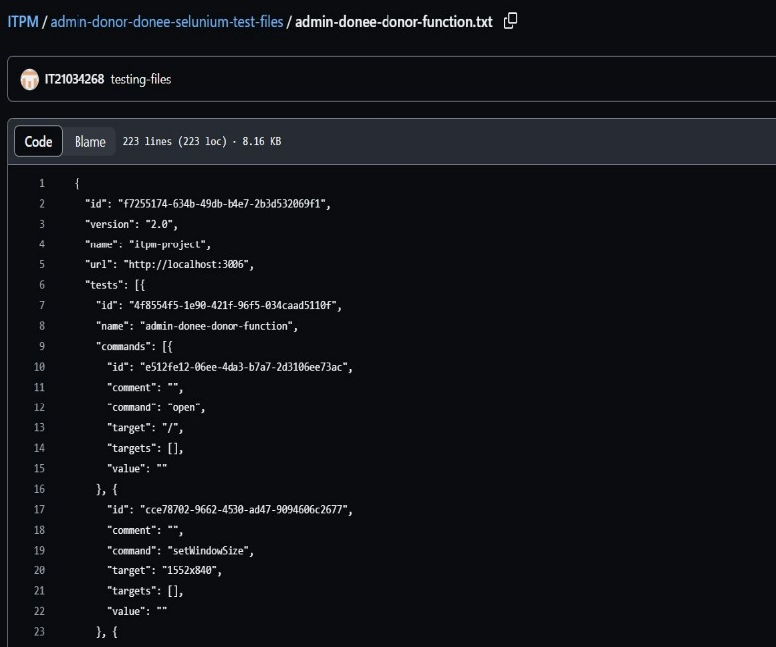**Automation test script**

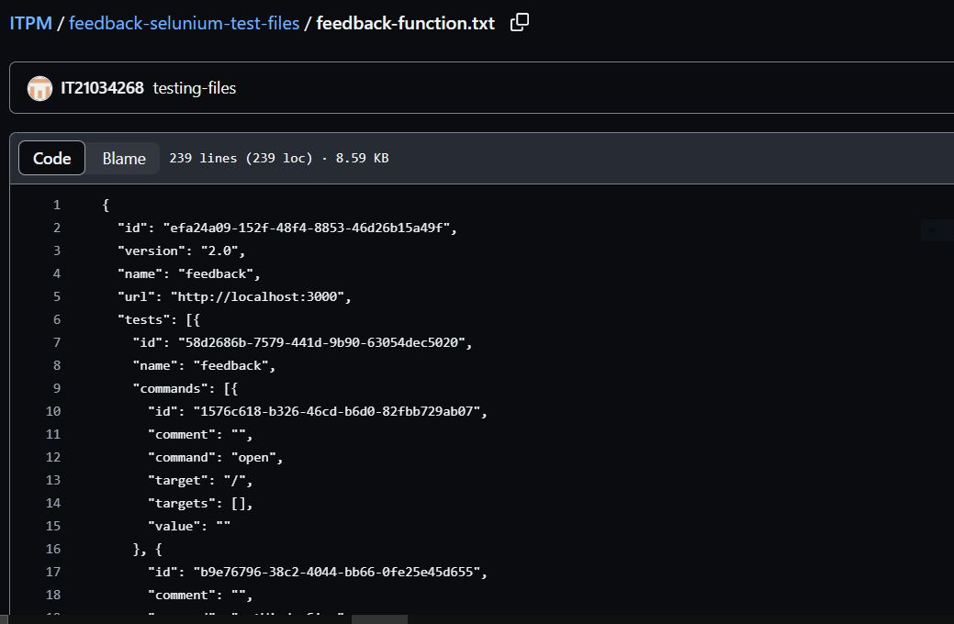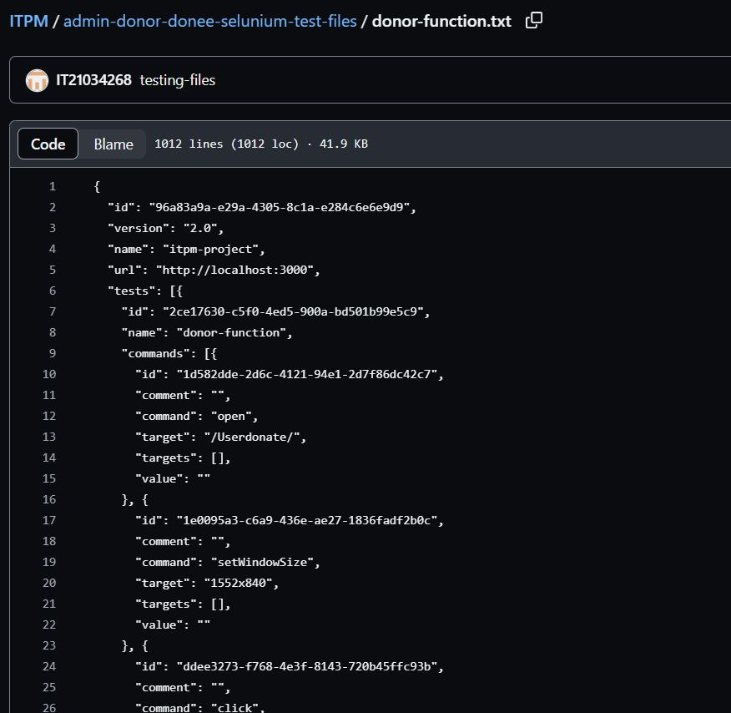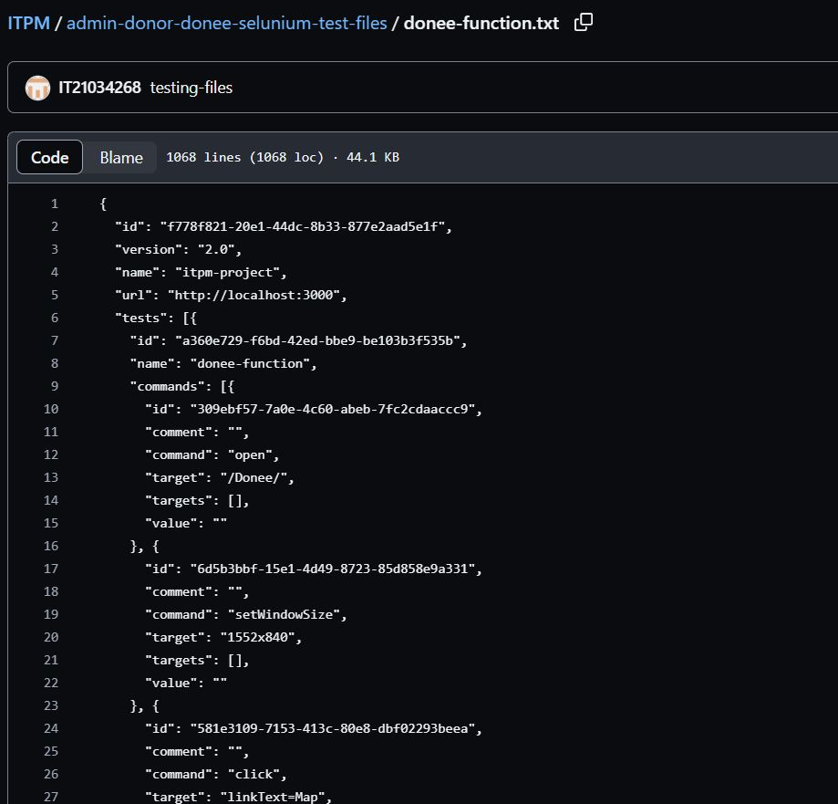

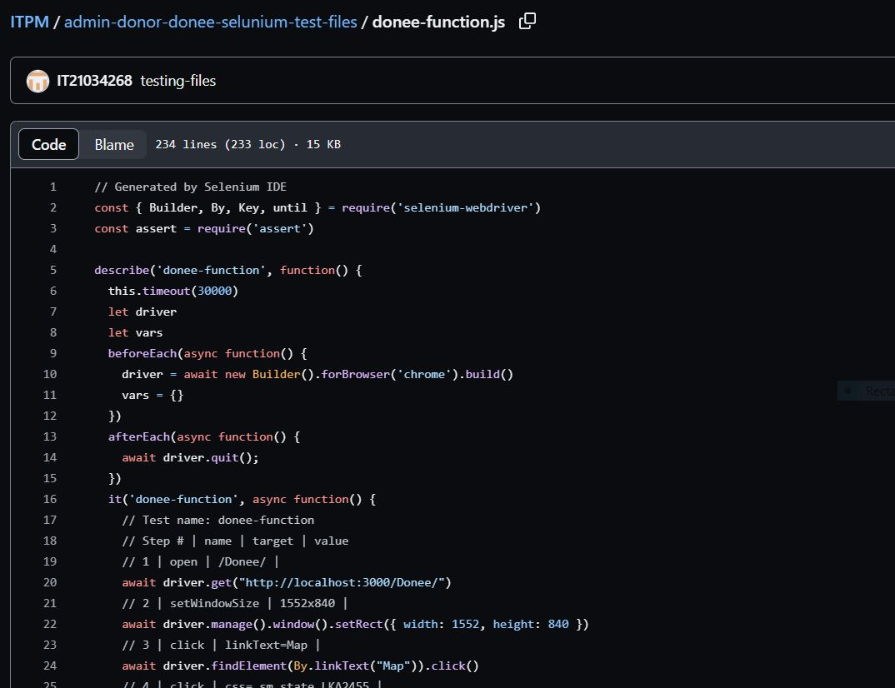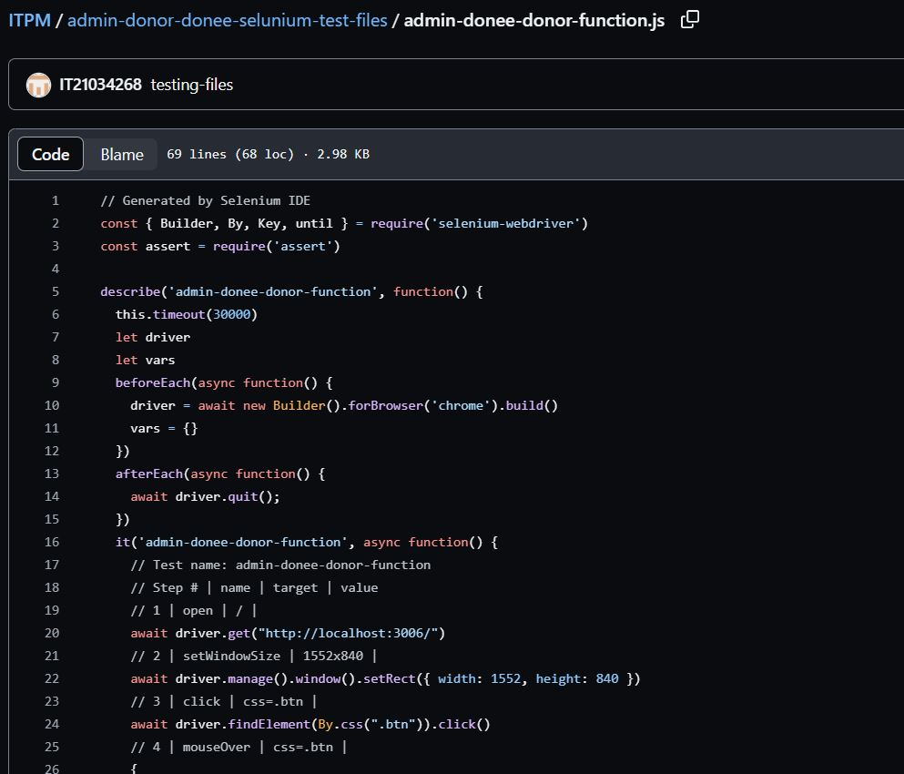

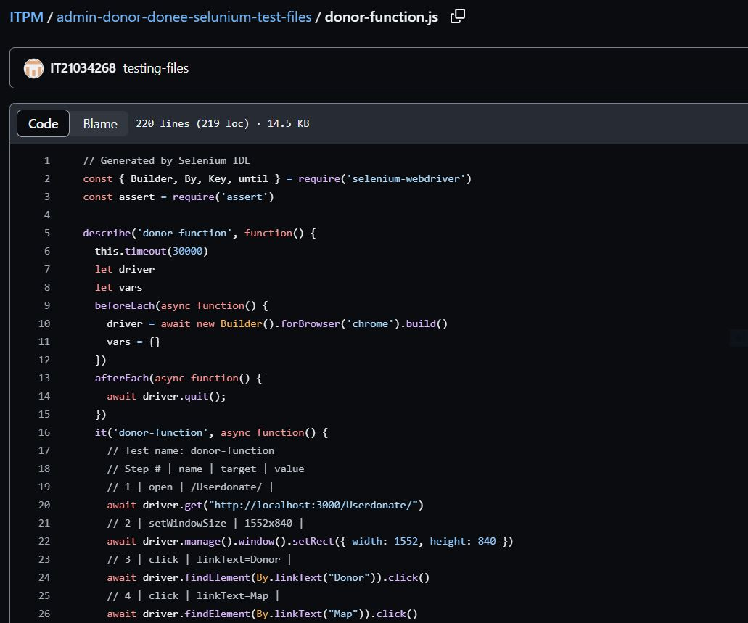

1. **Selenium IDE before/after running the test case**



